**184. Template-Driven (TD) vs Reactive Approach:**

* Instructor: Before diving in the actual code, it's super important to understand that Angular actually offers two approaches when it comes to handling forms .
* It offers the template-driven approach, which is called like this because there, you simply set up your form in the template, in HTML code, and Angular will automatically infer the structure of your form, will infer it which controls your forms, has which inputs, and makes it easy for you to get started quickly .
* It also has a more complex approach, the reactive approach .
* There, you actually define the structure of the form in TypeScript code .

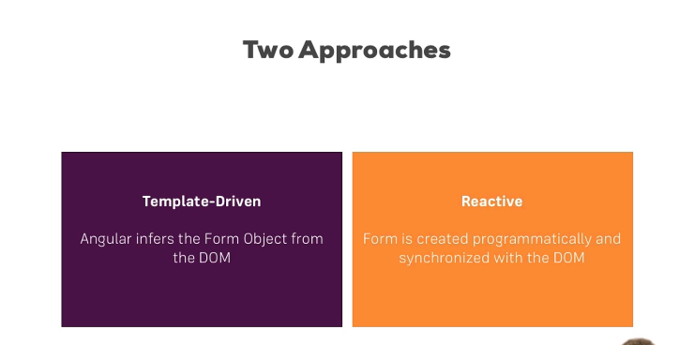

* You also set up the HTML code, and then you manually connect it, which might sound more complicated than it is in the end, and therefore, it gives you greater control over it .
* You can fine-tune every little piece about your form .
* Now, in this module, we're going to have a look at both approaches .
* In the next videos, I'm going to start with the template-driven approach, which is fine for a lot of use cases, before we then dive into the more advanced reactive approach .